# Group Project Part 1c – Work to be completed with your group (60 points)

This part of the assignment to be completed by the members of your group. Collaboration with other people not in your group is not allowed. You must only work with members of your own group. The project is open book and open notes and you may use any resource at your disposal except for directly soliciting advice or input from others outside of your group. Please make sure all sources are cited. Do NOT give or share this assignment with others.

Please answer the questions listed below and submit your answers via the eLearning “Homework 1 Part 3 - Group Submission” submission. You may answer the questions directly in this document. Please make sure you answer all parts of each question.

The following information is used to answer questions 1, 2, and 3.

Project Description

The new software-controlled conveyor belt is an exciting project that moves and positions items on a conveyor belt with a high degree of accuracy (< 1 millimeter of error). The proposed project will produce a new system capable of automating the movement of a wide variety of warehouse materials commonly used in order fulfillment. The following information has been developed for you to use in completing the exercises.

Assumptions and Notes

A seven-day workweek is used for the whole year. No holidays.

An 8-hour workday or 56-hour workweek is used. Overtime is not allowed.

The project should start on January 1 of the next year.

No splitting of activities is allowed.

No partial assignments are allowed (i.e. 50%). All resources must be assigned 100%.

Resources of a particular type have identical capabilities and may be substituted for each other. Hence, when working with resource type having multiple people, please create a single project resource listing (e.g. “Design”) and assign the resource a percentage value corresponding to the number of people (e.g. 200% for two people).

Similarly, when working with resource types having a single person, create a single project resource listing and assign it a value of 100% to indicate a single person.

Activity durations are fixed meaning adding resources to an activity does not decrease the duration of the activity.

***Warning: Save your work frequently and make backup files as you answer each part.***

Table 1

|  |  |  |  |  |
| --- | --- | --- | --- | --- |
| **Activity** | **Description** | **Resource Type** | **Duration (days)** | **Preceding Activity** |
| 1 | System architecture | Design | 40 | - |
| 2 | Hardware specifications | Development, design | 50 | 1 |
| 3 | Kernel specifications | Design | 20 | 1 |
| 4 | Utilities Specification | Development, design | 25 | 1 |
| 5 | Hardware Design | Design, development | 70 | 2 |
| 6 | Disk drivers | Assembly, development | 90 | 3 |
| 7 | Memory management | Development | 75 | 3 |
| 8 | Operating system documentation | Design, documentation | 15 | 3 |
| 9 | Routine utilities | Development | 60 | 4 |
| 10 | Complex utilities | Development | 90 | 4 |
| 11 | Utilities documentation | Documentation, design | 10 | 4 |
| 12 | Hardware documentation | Documentation, design | 10 | 5 |
| 13 | Integration first phase | Assembly, development | 35 | 6,7,8,9,10,11,12 |
| 14 | Prototypes | Assembly, development | 65 | 13 |
| 15 | Serial I/O drivers | Development | 85 | 13 |
| 16 | System hard/software test | Assembly | 15 | 14, 15 |
| 17 | Order printed circuit boards | Purchasing | 5 | 16 |
| 18 | Network interface | Development | 25 | 16 |
| 19 | Shell | Development | 20 | 16 |
| 20 | Project documentation | Documentation, development | 20 | 16 |
| 21 | Assemble preproduction | Assembly, development | 15 | 17, lag 5 days* |
| 22 | Integrated acceptance test | Assembly, development | 20 | 18, 19, 20, 21 |

* Task 21 cannot begin until 5 days after task 17 has been completed

Table 2

|  |  |  |
| --- | --- | --- |
| **Resource Type** | **Number Available to Work on Project** | **Cost ($/hr)** |
| Design | 2 | $225 |
| Development | 2 | $130 |
| Documentation | 1 | $75 |
| Assembly/Test | 1 | $65 |
| Purchasing | 1 | $50 |

Part 1c Question 1 (30 points)

**Do not include resource assignments in your answer to Question 1. Only include activities, activity durations and dependencies.** When entering task information in Question 1, please make sure the schedule mode is set to “Manually Scheduled” instead of “Auto Scheduled” as in Figure 1. Schedule mode may be set using the “Task Information” dialog or via the “Manually Schedule” button on the “Task” ribbon.

Also, please make sure the “Level Manually Scheduled Tasks” check box in the “Resource Leveling” dialog box is deselected as in Figure 2. Leveling options may be viewed using the “Leveling Options” button in the “Resource” ribbon. Both are the default settings in MS Project 2019; however, if you’ve used project for other purposes, the default settings may have been adjusted.

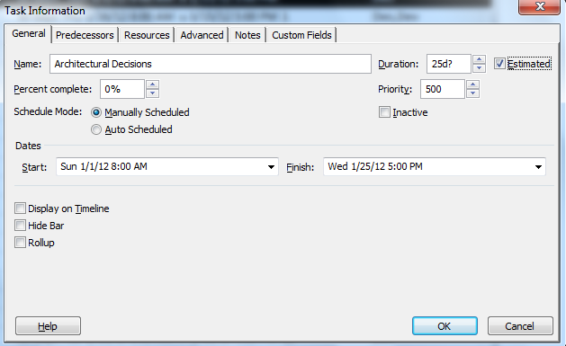 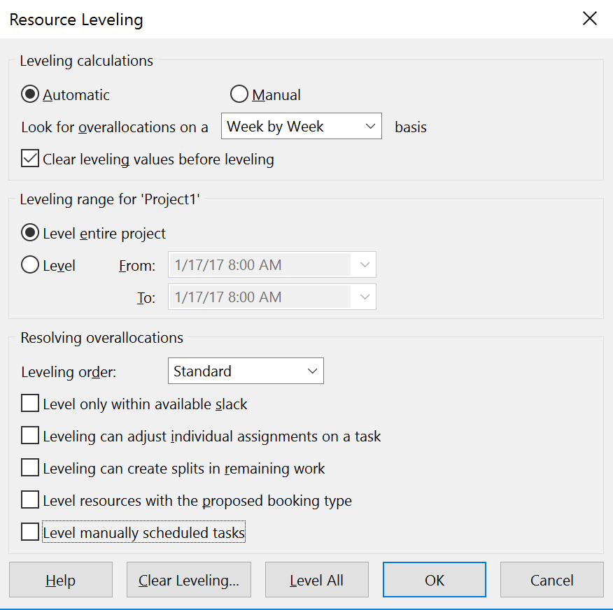

**Figure 1 – Initial Task Information Dialog Figure 2 – Initial Resource Leveling Dialog**

a. Create the project described in table 1 in Microsoft Project and paste a screenshot of the bar (Gantt) chart of the project highlighting the critical path below. Please make sure all tasks are clearly labeled with their corresponding task name. Your Gantt chart should also include a summary task. DO NOT INCLUDE THE RESOURCE ASSIGNMENTS LISTED IN THE THIRD COLUMN OF TABLE 1.

b. Include a screenshot out of early start, late start, early finish, late finish, total slack and free slack in table form. The screenshot provided should also include a summary task for the project.

c. What is the scheduled finish date?

* 12/16/24

d. How many days will the project take to complete?

* 350 days

e. What percent of project activities are on the critical path?

* 50% (11 activities/22 activities)

f. What activity has the most total slack? What activity has the most free slack? Explain the difference between free slack and total slack.

* Total Slack: Operating System Documentation (Activity 8: 95 days) & Utilities Documentation (Activity 11: 95 days)
* Free Slack: Operating System Documentation (Activity 8: 95 days) & Utilities Documentation (Activity 11: 95 days)
* Free slack is the amount of time that at ask can be delayed without impacting the subsequent task while total slack is the amount of time a task or a project can be delayed without impacting the overall project completion time.

g. What is the total slack for the project as a whole? Use the summary task to help answer this question.

* 0 days

h. Is it better to have a higher percentage of activities on the critical path or a lower percentage of activities on the critical path? Explain your answer.

* The chances of the project being delayed are higher if the percentage of activities on the critical path is more. Hence, it is better to have a lower percentage of activities on the critical path because you face less risk of delays, and the critical path in the project becomes shorter.

Part 1c - Question 2 (30 points)

Using the project you created in question 1, assign resources to perform each activity. The project is limited to the resources listed in Table 2. All scheduled activities must include a list of resource commitments.

1. After assigning resources, what is the cost of the project?

* $1,366,600.00

1. Which, if any, of the resources are over-allocated? List the resources that are over-allocated.

* Design, Development, & Documentation

1. Try to resolve the over-allocation problems without extending the duration of the project using the resource leveling feature of MS Project. To level resources without extending the duration of the project, make sure the check boxes for “Level only within available slack” and “Level manually scheduled tasks” are both selected. Also, assume “Leveling can adjust individual assignments on task”, “Leveling can create splits in remaining work”, and “Level resources with the proposed booking type” are deselected. See Figure 3 for the correct leveling settings?

Which, if any, of the over-allocated resources are no longer over-allocated?

* Documentation

Which, if any, of the resources are still over-allocated?

* Design & Development

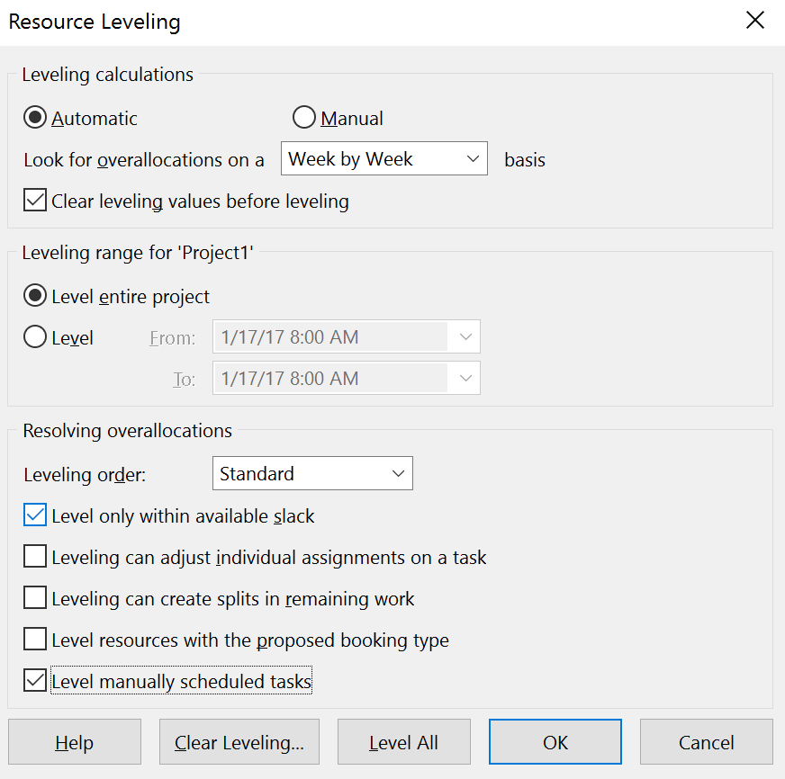

**Figure 3 – Resource Leveling Dialog for question 2b**

1. Include a Gantt chart and schedule table after leveling only within available slack. Please include a summary task and make sure all tasks are clearly labeled with their corresponding task name.

1. What is the impact of leveling within slack on the percent of project activities on the critical path?

* Leveling within slack increased the percent of project activities on the critical path. Eight activities got added to the critical path, resulting in a total of 19 activities on the critical path and a percentage of 86.36%.

1. Assume you cannot add additional resources and the project is resource constrained.

How many days will the project take after resolving all over-allocation problems?

* 495 days

What is the scheduled finish date?

* 5/10/25

See Figure 4 for the correct leveling settings. After leveling your project, change the scheduling mode for all tasks to “Auto Schedule” as in Figure 5 and review all tasks in the project to ensure no problems exist.

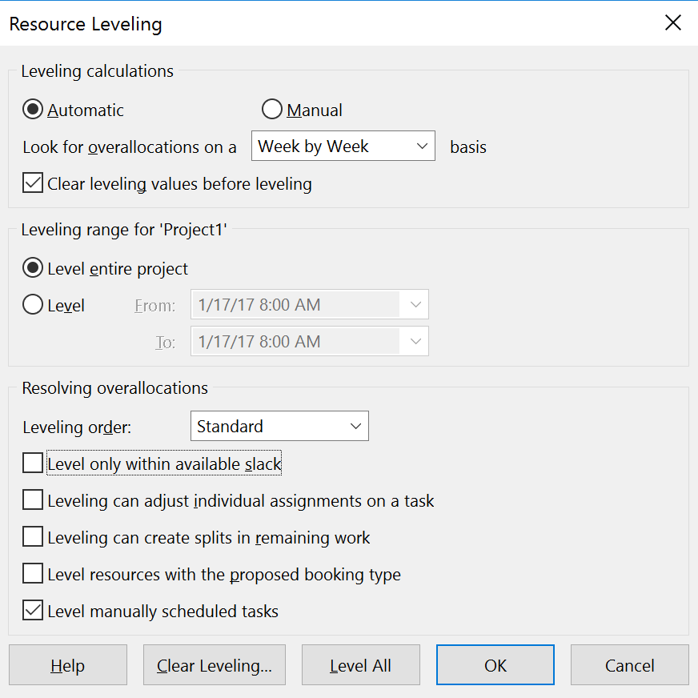 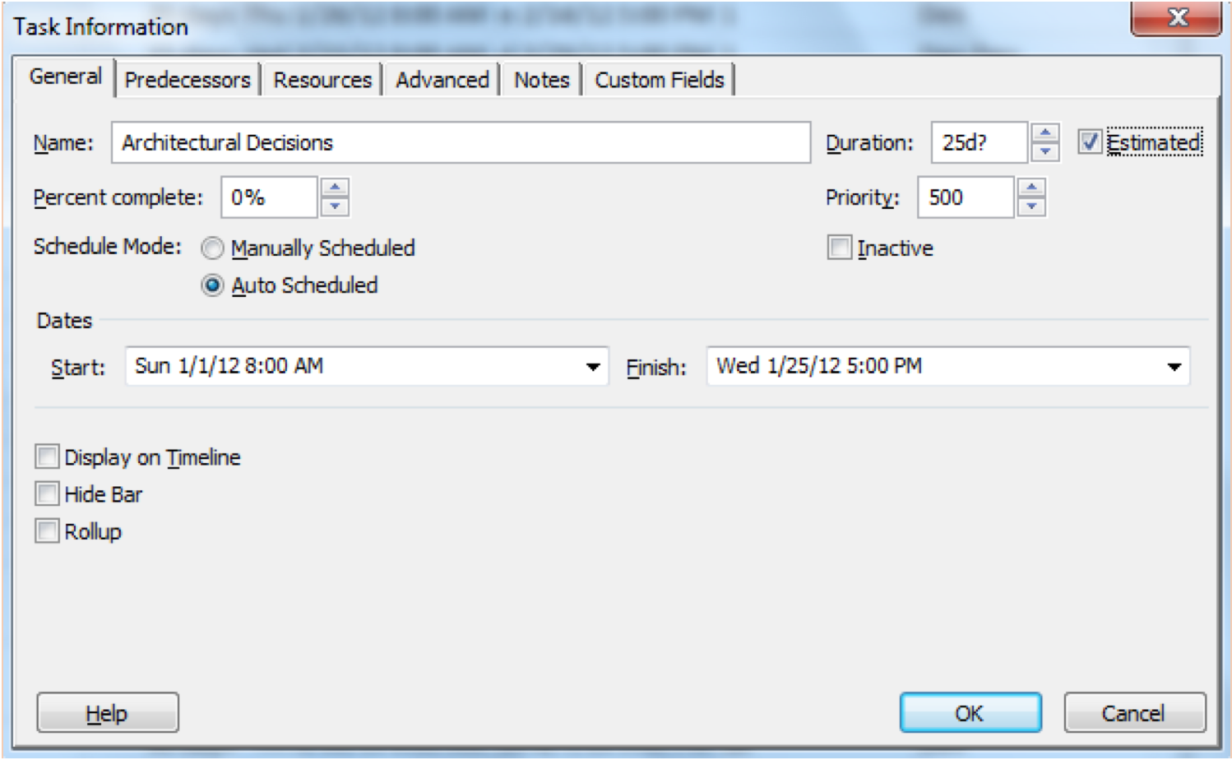

**Figure 4 – Resource Leveling Dialog for Question 2e Figure 5 – Task Information Dialog for Question 2e**

1. How does the schedule in 2f compare to the schedule in Question 1? Why did the number of days to complete the project in 2f increase?
   * The schedule in 2f added 145 days (about 5 months) to the project, lengthening the overall project schedule. One reason the days increased is because to fix the overallocations, the Auto Schedule feature postponed the finish dates of certain activities. For example, activity 3 used to have a finish date of 3/1/24; with the Auto Schedule feature, the new finish date is 4/5/24.

h. What is the total cost of the project after resolving all over-allocation problems in step 2f? How does this cost compare with the cost in 2a?

* After resolving the over-allocation problems, the project cost is $1,366,600.00. The project cost in 2h remains the same as 2a.

Part 1c – Team Member Contributions (0 to -100)

List and briefly describe the contribution of each team member on this assignment. The description should be one or two sentences at most.

Instead of assigning different tasks to each team member, we all joined on Teams call multiple times throughout the week to work on the project together. While one person shared the screen for Microsoft Project, we all verified the instructions were followed and came to one conclusion for each answer.